**INFO PACK Kick Off**

**ART ConnectiON**

**Partnership for Creativity in the Field of YOUTH**



MÁLAGA, SPAIN

10th and 11th NOVEMBER 2021

**SOME INFORMATION ABOUT OUR PROJECT…**

ART ConnectiON is a Strategic Partnership for Creativity in response to COVID created by five entities from Spain, Italy, Poland and Turkey, among which are associations in the field of youth and inclusion, municipalities and educational centers.

The context and needs that we share is caring for young people with functional diversity and fewer opportunities living in rural areas, who have been especially affected by covid-19 as they experience greater isolation due to the digital gap and social exclusion existing in these areas, but who also recognize the strengths of the creative and cultural activities that they carry out to maintain their mental and physical well-being to face these difficulties. They propose the need to develop their social, digital and artistic skills to promote social inclusion and the dissemination of inclusive creativity through digital media.

To answer these common needs, we propose a Strategic Partnership for the development of Innovation to tackle the horizontal priorities of "Development of Skills and Inclusion through Creativity and Arts" and "Innovative Practices in a Digital Era" plus the YOUTH priority of promoting engaging, connecting and empowering young people.

As main topics we tackle attention to disabilities and special needs in the new reality of covid- 19, the development of digital tools and the support of creativity and culture as tools for inclusion and mental well-being in circumstances of crisis and social isolation.

**Objectives:**

**About the project:**

1. Developing and disseminate innovative tools that combine CREATIVITY (dance, music, theater, crafts) and DIGITAL TOOLS (YouTube, social networks and videoconferences) to address the needs of inclusive care and education for young people with disabilities on key issues for personal development (equality gender, emotional management, social skills, independence, digital security and mental well-being) in the new covid-19 reality.
2. Creating more inclusive youth mobility opportunities for young people with disabilities.
3. To increase visibility of young people with disabilities in social media, promoting alternative models.
4. Training and empowering youth workers, social educators and teachers, through the sharing of needs, good practices and training in creative tools and digital media for inclusion.

**About the Kick off Meeting:**

In this first offline meeting, we will establish the base of our cooperation during the project. We will share the timeline of the project, goals, outputs and DEOR strategy as well as we will talk about the role of each partner.

We will dedicate an essential part to discuss the first intellectual product "Youtubers for Inclusion", key part of our project.

Especially in this meeting we will have the opportunity to share the circumstances experienced during the pandemic, how the activities that we have been carrying out in each entity have evolved, how digital media have been used to continue attending people, giving an opportunity to share in common of good practices that can contribute to the development of the IO1.

**COUNTRIES AND PARTICIPANTS:**

4 countries (Italy, Poland, Spain, Turquey,) and 5 entities, represented by one represent each: IMAGINA, Strauss, Centrum Wolontariatu Kielce, Besiktas and High School Valle del Sol

|  |  |  |
| --- | --- | --- |
| NAME | TYPE | COUNTRY |
| IMAGINA | NGO | Spain |
| ASSOCIAZIONE CULTURALE STRAUSS | NGO | Italy |
| REGIONALNE CENTRUM WOLONTARIATU | NGO | Poland |
| Besiktas Municipality | PUBLIC BODY | Turkey |
| IES VALLE DEL SOL | SECONDARY SCHOOL | Spain |

**WHEN:**

The dates will be from the 09TH NOVEMBER to the 12th of NOVEMBER 2021 (including arrival and departure days).

The venue will be in “Los Álamos”, a neighborhood of Torremolinos. (Málaga).

Torremolinos was the first of the [Costa del Sol](https://en.wikipedia.org/wiki/Costa_del_Sol) resorts to be developed and is still the most popular in the region. As the name Coast of the Sun implies, Torremolinos enjoys one of the best climates in Europe. It has long, dry summers with relatively low humidity, and mild winters with occasional, though heavy, rainfall. The town benefits in the summer from cool sea breezes predominantly coming from Africa, although this does mean a fair amount of Sahara dust. Temperatures normally hover around 30 °C (86 °F) in the summer and 17–19 °C (63–66 °F) in the winter.

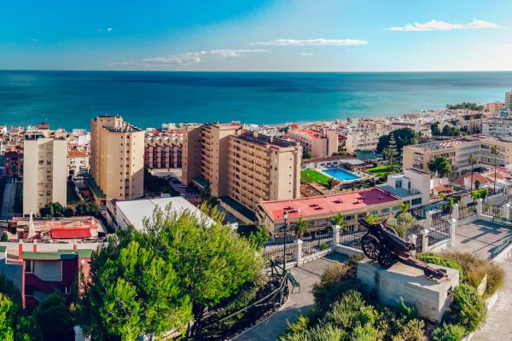

**HOTEL: COSTA DEL SOL HOTEL BOUTIQUE:**

<https://www.costadelsolhotelboutique.com/>

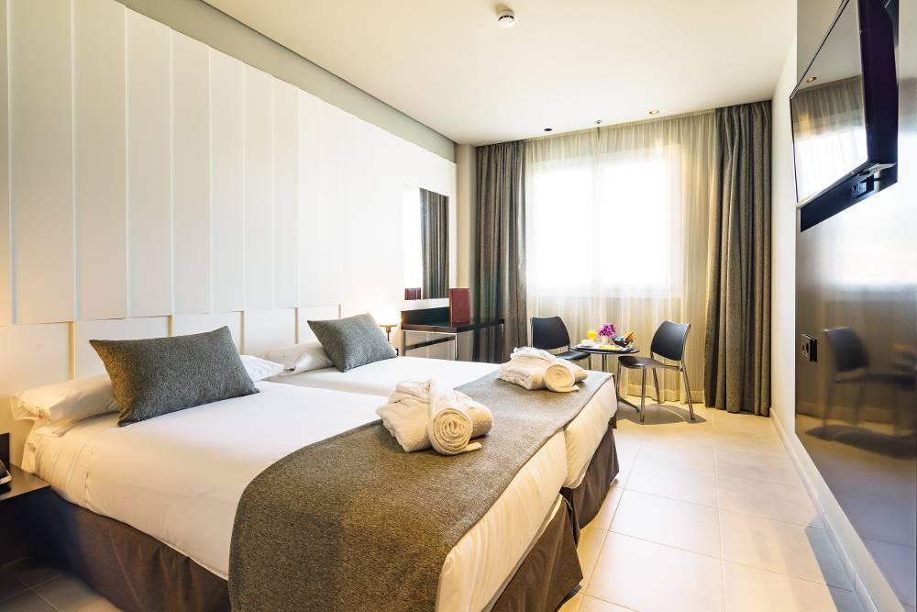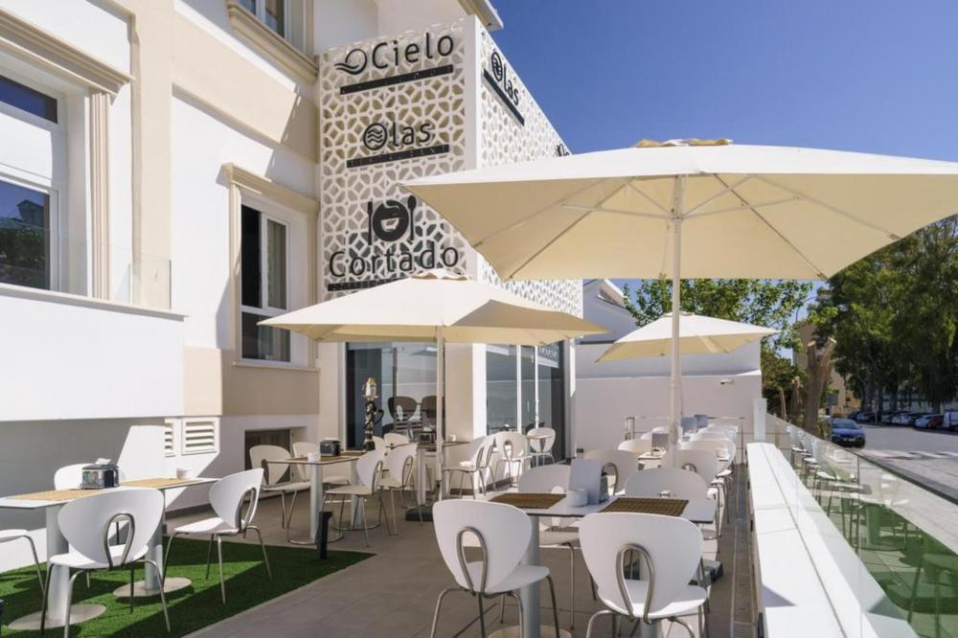

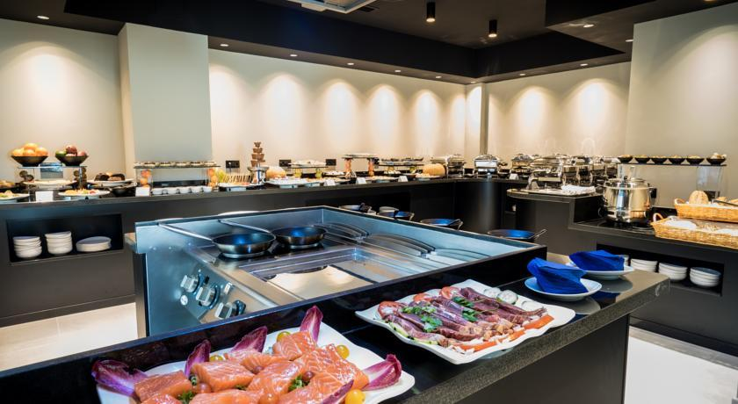

**Check IN Time: 9th of NOVEMBER at 18.30h**

**Check OUT Time: 12th of NOVEMBER at 12.00h**

**MEALS:**

Breakfast and dinners will be held at the hotel, one drink per person will be included in dinners.

For lunch we will go to different local restaurants depending on the schedule of activities.

**FINANCIAL CONDITIONS:**

The cost of the food and accommodation will be covered 100% by IMAGINA, furthermore, for travel costs will be refund according to the travel distance and Erasmus + Guides 2020.

-For travel distances between 500 and 1999 KM: 275 € per participant (Italy).

-For travel distances between 2000 and 2999 KM: 360 € per participant (Turkey and Poland).

The reimbursement of travel costs will be done similar to KA1 projects, presenting boarding passes, travel tickets and invoices of the mean of transport.

**HOW TO ARRIVE TO TORREMOLINOS?**

We will be only 8 km from Malaga airport

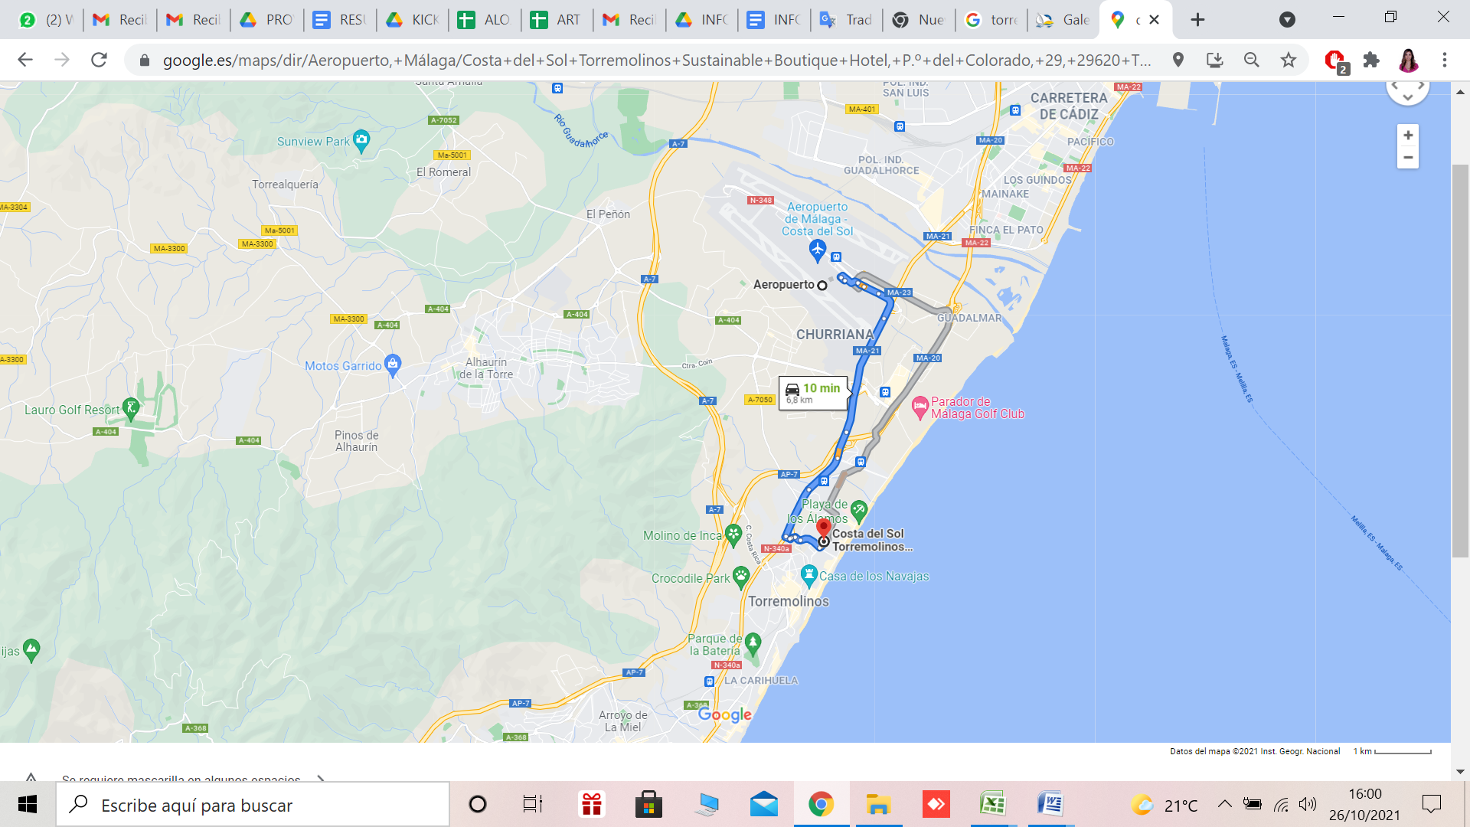

If you are in Málaga City, you will take the Train CERCANÍAS, Line C1 and take the one at 18.10h.

1. Go to the María Centro Alameda train stop (it leaves every 35 minutes).

2. Bye a SINGLE ticket at the vending machine to LOS ALAMOS.

3. You will be on this train about 17 minutes, and then you have to get off the train at the stop LOS ALAMOS (which is the 6th stop: María Zambrano / Victoria Kent / Guadalhorce/ Aeropuerto / Plaza Mayor / Los Álamos).

7. The hotel is a 20 minute walk from the train station.

We will pick you up in Los Álamos train station at 18.30 and take you to the Hotel.

**MEETING POINT “LOS ALAMOS” TRAIN STATION ON THE 9TH NOVEMBER AT 18.30H.**

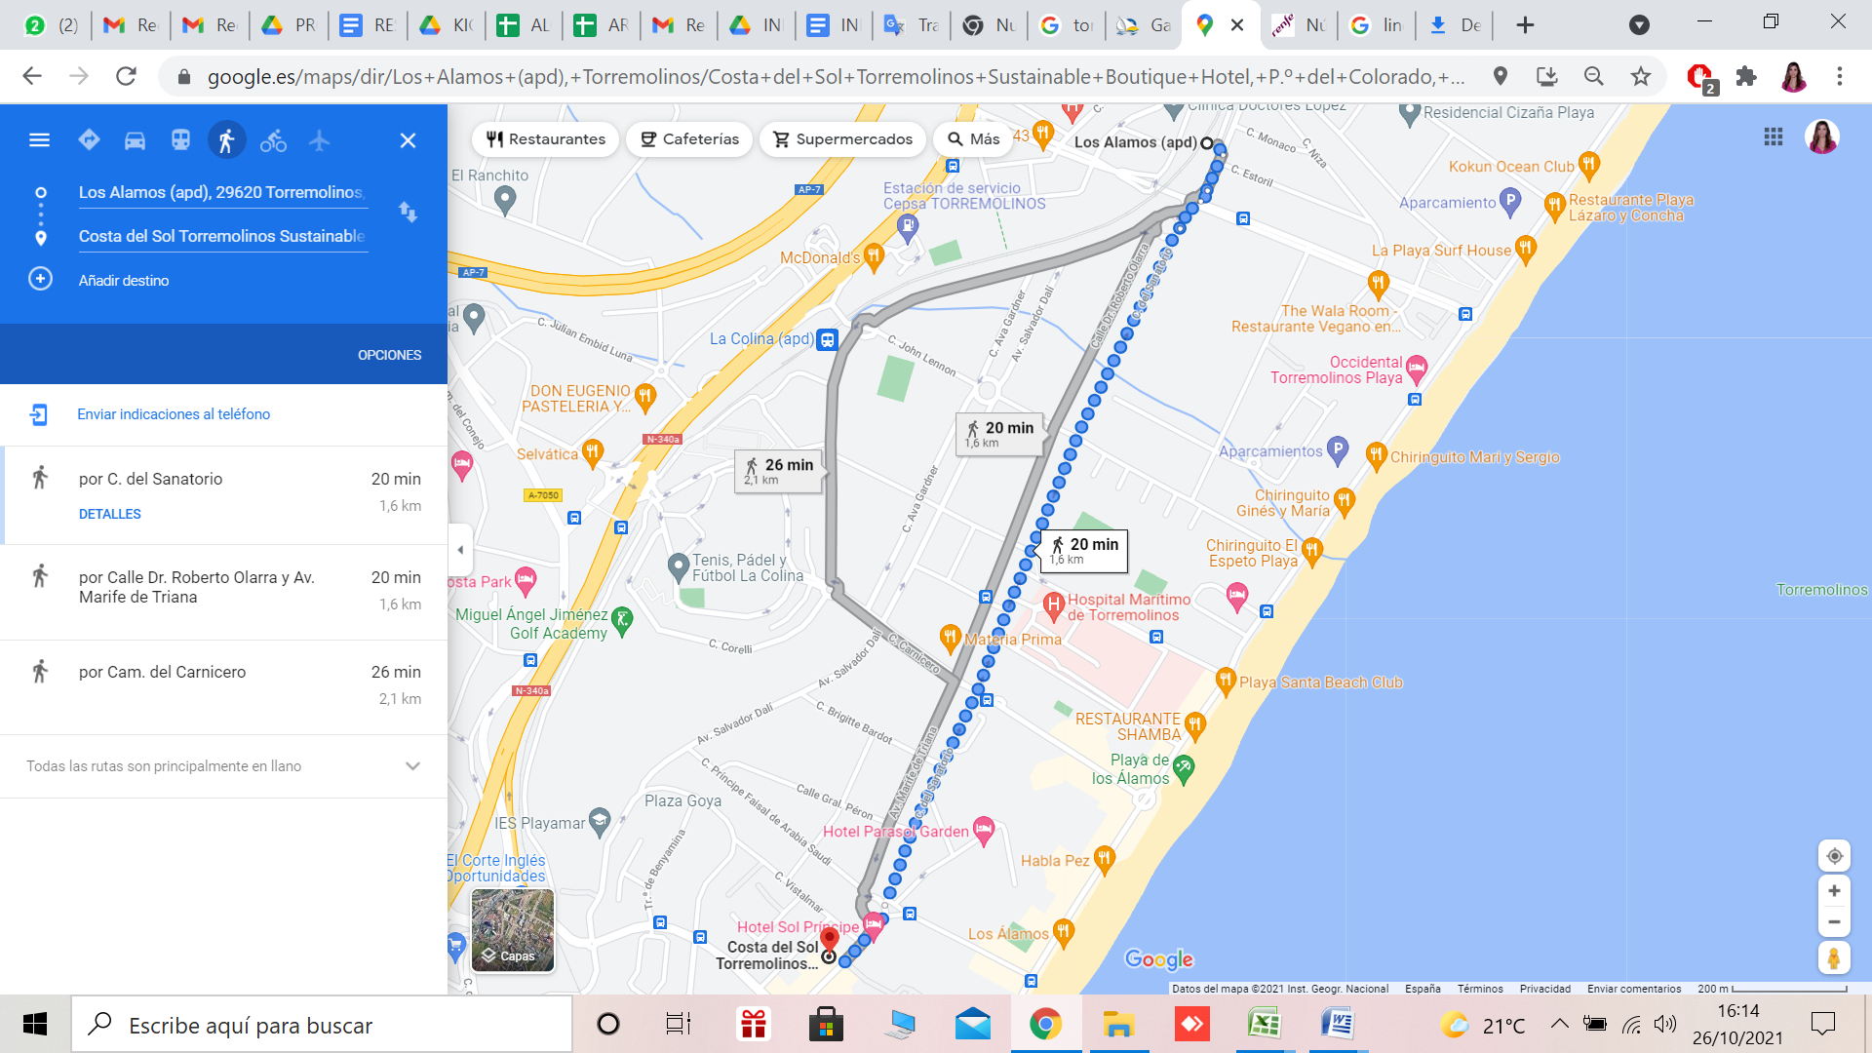

**COVID INFO:**

* We will be wearing **masks** during the activities that take place **inside** of the building.
* Moreover, everyone need to follow all the official COVID-19 measurements in Andalucía, which are:
* Mandatory masks inside (including public transport, cinemas, malls, restaurants and bars when not consuming), or when social distancing is not possible outside
* Please, have **COMMON SENSE** regarding this issue. There is a lot of work behind this project, let’s be responsible! Avoid close contact with people outside the project, follow the hygiene measurements, avoid crowds and keep a watchful eye on any symptoms.
* We strongly recommend to have a travel insurance that can cover the expenses of the travel in case someone could be positive during the travel. Imagina cannot cover the expenses of a possible quarantine in Spain.

**WHAT TO BRING:**

November is usually a month with soft temperatures during the day but during the night, it could be a quite cold so please, be prepared for these conditions and bring these important items with you:

* Comfortable and warm clothing;
* Towels and toiletries will be provided by the hotel.
* Some items to present your organization (leaflets, brochures…).
* Information about your background:
* Target group of people with disabilities: what activities your organization is involved in.
* Main difficulties that your organization had during covid to keep on with these activities.
* Main needs of your organization regarding inclusive and digital tools.
* Your ID/passport and insurance documents (**European Health Insurance Card// travel or healthy private insurance)**;
* Your VACCINE CERTIFICATION.
* Good Mood!! ☺

**HOW TO CONTACT US:**

For further information and to send the information required:[imaginaerasmusplus@gmail.com](mailto:imaginaerasmusplus@gmail.com)

To contact us by phone in case you need it:

María J. Subires: +34 629 83 38 89 – Laura Aguilar: +34 606 76 46 85

Our address: Asociación de Desarrollo Social Participativo IMAGINA, C/Soleares, nº 12, Álora, 29500. Málaga, España.

**LOOKING FORWARD TO MEETING YOU!!**

**SCHEDULE:**

|  |  |  |  |  |
| --- | --- | --- | --- | --- |
| **Time/Date** | **Day 0- Arrival Day-Tuesday**  **9th november** | **Day 2-Wednesday**  **10th november** | **Day 3-Thursday**  **11th november** | **Day 4-Friday**  **12th november** |
| **08h30-09h30** | Arrivals | Breakfast | Breakfast | Breakfast |
| **Morning Session 1**  **10.00-11.30h.** | NGO PRESENTATION  AND BACKGROUND’S NEEDS  GOALS AND RESULTS OF THE PROJECT | INTELLECTUAL OUTPUT  &  DERIVERABLES  +DEADLINES | Good bye and Departures |
| **11h30-12h00** | COFFEE BREAK | COFFEE BREAK |
| **Morning Session 2**  **12.00-13h30** | TIMELINE OF THE PROJECT  DATES OF MEETINGS | DEOR  BUDGET  INTERNAL PARTNERSHIP AGREEMENT |  |
| **14.00-15.00h.** | LUNCH | LUNCH |
| **15.00- 16.30** | COHESION  ACTIVITY | STUDY VISIT |
| **Afternoon**  **Session 1**  **16.30-18.00h.** |
| **Coffee Break**  **18.00-18.30h.** | COFFEE BREAK |  |
| **Session 2**  **18.30-20.00h.** | Accomodation  Check-in | COMMUNICATION STRATEGY  THE PROBLEM’S BOX | STUDY VISIT |
| **20.00-20.30h.** | REIMBURSEMENT | STUDY VISIT |
| **20.30-21.30h.** | DINNER | DINNER | DINNER |
| **Evening**  **22.00-22.30h.** | GETTING TO KNOW EACH OTHER | NIGHT IN MALAGA | FREE NIGHT |