**In what ways can I improve the quality of the 6 CliPs climate change course?**

Practitioner inquiry of Wim Peeters, PONTOn vzw

Tutor of the course and future course organiser.

The basic question splits up in two secondary questions:

1. What are the strengths and the weaknesses of the 6 CliPs training course of April 2023?
2. Drawing conclusions, how should the course be reshaped for future use, keeping at least the main goals?
3. **Introduction**

The 6CliPs project, “Six climate projects for fight against climate change” (1) is the key initiative upon which this practitioner inquiry (1) is built.

The headlines of this project, mirrored in the course are:

Topics: Environment and fight against climate change, promoting interest and excellence in science, technology, engineering, and mathematics (STEM), and the STEAM approach, Recognition of learning outcomes for participants in cross-border learning mobility; Initial and continuous training for teachers, trainers and other education staff.

Objective 4 of 6CliPs is: to ensure continuous collaboration, a professional learning community (PLC) of STEM teachers from the 3 schools is formed. A 5 day training in the south of Spain, with collaboration of invited experts in the fields of education and climate contributes heavily: they learn to learn together and exchange knowledge on environment and climate issues of their specific contexts. To train these STEM teachers in a PLC setting in the fields of Inquiry Based Learning, STE(A)M teaching and learning strategies, evidence based teaching (practitioners inquiry=PI) and educational research.

Objective 2: teachers and students write a double report on the local context on WEP: one for "adults" by the teachers, and one for and by students. The first describes regional and local needs and the policy.

Adaptations done during development of the course: the course followed the steps of the STE(A)M approach, as described in the STE(A)M-it project (2).

Hence, the main goals of the course are:

* Establishing a professional learning community of the participants
* Learning by doing, facilitated by experts, about Inquiry Based Learning, Practitioner Inquiry and the STEAM cycle
* Learning from experts about the situation of climate change on the level of the close environment of the venue, local level, and regional level by doing excursions
* Developing and elaborating all steps of the STEAM cycle in a concrete small project in situ
* Developing a strategy for transferring all learnings to the own practice.

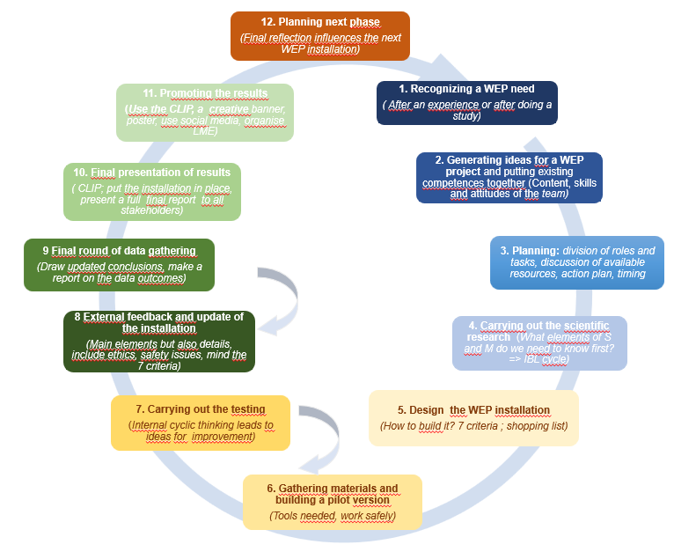

*The 12 step STE(A)M cycle*

The main outcome of 6CliPs for PONTOn as an organisation, is mentioned on p.65 of the proposal (2): “*5. For PONTOn, the basics and the experience, also the feedback of the participants, of the one week training session, will be used to develop and organise several versions of this training: a version for younger children (11-12 years), one specifically for girls, for older learners separately ( 6-18 years old) for students of vocational STEM schools. The trainings can be given in different settings of participants. The combination of Fight against Climate Change, outdoor learning and STEM education is very powerful and has a lot of potential.”*

1. **Method and data gathering for this PI embedded in the activities of the training:**

The course was given as a training for the 6 CliPs project. The “teach as you preach” approach was used, however at some moments it was necessary to explain explicitly the steps participants went through. At the start it was stated that learnings needed to be written down in 2 steps: a “personal notebook” (paper and pencil) for everything that was perceived as a learning moment, and that contains also many “other” kinds of information, and the digital, online logbook that was kept to indicate the principal learnings on the level of the school and the project. (Dataset 1). The milestones of the event were the 12 steps launched as STE(A)M steps, in which the first was determined by the project itself. However, 3 activities supported the “study” aspect of step 1: A walk in the nearby environment, guided by a local goat keeper, an introduction to Organic Agriculture in the Guadalhorce valley, explained by a local expert, and a visit to a nearby town, where a volunteer explained in details the regional, national and European strategy on solar panel fields. A tour of the venue was the first step in “Generating ideas”. The PLC activities contributed to getting to know each other’s background, interest and expertise. “Planning” was mainly guided by the structure of the course itself. The scientific research step was preparing for some basic principles of the installations that were foreseen. After 3 days a first SWOT feedback was organized. (dataset 2a) Two main ideas popped up: a “3D Herbal Garden” and “The use of the water from the spring”. After a brainstorming session with all participants, they split themselves in 2 groups. These “designed” in more detail the set up of the installations. After a shopping activity, and a visit to the recycling park, materials were put in place, building a pilot version of the small installation. During the free time all participants opted for the walk of the “Caminito del Rey”. During construction, testing was needed all the time to see whether the installations “worked”. Each group then played the role of “External” and gave feedback to the other group. This led to improvements. At the beginning of day 6, a short questionnaire gathered participants’ opinions on the use of the 2 step notebook. This was an innovation and needed to be reflected on explicitly.( dataset 3) A second SWOT was asked for after 6 days ( dataset 2b). At the beginning of day 7, a graphical expression of the learnings- specifically the highlights- was asked as dataset 4. During all activities each group took photos and videos in view of the presentations to be made. Each group needed an expert in video editing and two presentations (one PowerPoint and one video that was indeed produced) were done in the aula of the local organisation, attended by externals. At the very end, a short survey informed the course leader about several crucial aspects of the course (dataset 5). Interviews during and afterwards were taken as dataset 6.

1. **Datasets and analysis of data**

The data contain a lot of information on the quality of the event. For this PI only those data were taken that lead to conclusions that are of value for the inquiry questions.

**Dataset 1:** [Logbook](https://docs.google.com/document/d/1AhKk6a-8Gm83U9Xl_artro3xfIDSHpxPGGnCRgq2Ni8/edit?usp=sharing)

Quotes:

Where experimentation is highly encouraged and done.

Out of the ordinary, out of our comfort zone.

Really interesting venue, very unique.

 The variety of ideas that are used in Wim's place are amazing.

“He learned from the locals.”

“During the excursion with Yolanda, the goat shepherd, we learned that the olive trees are endangered due to the lack of water”

“Biological agriculture is increasing recently. Young people see opportunities in this area after the economic crisis…”

“we noticed the problem of the disappearance of agricultural areas due to the construction of solar power plants”

“Wim: please remember that we follow:”

“We started our day by analyzing the reason why we study STE(A)M.”

“The idea about having STE(A)M in one class and about how the education system needs to be changed.”

(reading the Logbook, and connecting to the STEAM steps, it is clear that teachers were very much into the STEAM cycle)

“The group then had to make designs of the proposed solutions”

“The brainstorming process is useful prior to formation of working groups - results of brainstorming could be surprising, however in that way you can get more ideas and combine more before determining the groups is surprising. But this way we get more ideas and combine more experiences.”

“Working group has to be challenged in order to find a solution (sometimes even pushed out of their comfort zone)”

“During the shopping, minor adjustments were already made to the plan”

“We need to guide our students through the IBL cycle in order not only to learn about climate change but also to develop skills and competences the IBL can offer.”

“We learned about some useful skills in the area of IBL methodology. For example the importance of the brainstorming”

“He scaffolded the group, in order to guide us in the direction he wanted, but then he stepped back again and let us take initiative and responsibility on how to solve the problems. “

“Students might need support at some point to keep them on the right track.” “However, we must keep it to a level that they still have the ownership of the project.”

Conclusions from the logbook:

- the venue was a very stimulating environment

- study of the environment, study visits and connecting to locals is very important

- participants understood the steps of the STEAM method applied during the week. The introduction was necessary, and maybe with some additional didactic materials the steps could become more clear.

- participants were aware of the fact that this course was a fast forward simulation of what should happen at their schools, including their role as teacher, and the role of the students taking ownership of the process.

- collaborative work was crucial, “the group” and “we” are used a lot in the Logbook.

- participants always felt conscious of what they were doing, and also confident

- some suggestions to improve the course were given:

- to pay enough attention to the IBL method

- to pay enough attention to brainstorming and reflection

- to keep guiding participants through the 12 STEAM steps

- to invite the experts to the venue

**Dataset 2** [SWOT feedback](https://docs.google.com/spreadsheets/d/19O2GmMdThsgI0TMFEqQ0TFs7p-hp0Ya9QFVFCBaMgtQ/edit#gid=425614955):

The first SWOT was answered by 7 participants from the 3 schools, the second one by 9 participants 5 now including 2 participants from IMAGINA).

Conclusions on each of the items:

Main strengths: (summary of the readings)

* Real life experience of the STEAM approach ( 7 times mentioned in 2nd SWOT)
* The IBL method as a learning strategy ( 3 directly, 2 indirectly)
* The realisation of a real installation ( 6 explicitly)
* The collaboration between participants (discussions): 5 times explicitly, sometimes indirectly, using “we” as proverb.

Weaknesses: (summary of the readings)

* Lack of reflection time: 5 explicitly
* The recycling park: one only mentioned this

Opportunities: (summary of the readings)

* To elaborate the brainstorming phase more
* To have more experiments on IBL with climate change as subject ( 3 times directly)
* To exploit the location even more ( 2 times)

Threads: (summary of the readings)

* The combination of practice and theory must be carefully monitored.
* The strict timetable
* (other are about implementation at school)

**Dataset 3:** [Survey on the use of the personal notebook](https://docs.google.com/forms/d/1nrzTZ2C-fa2dxqNJxRYYNOxO3xtI8qpoEbG_OryPfss/edit#responses)

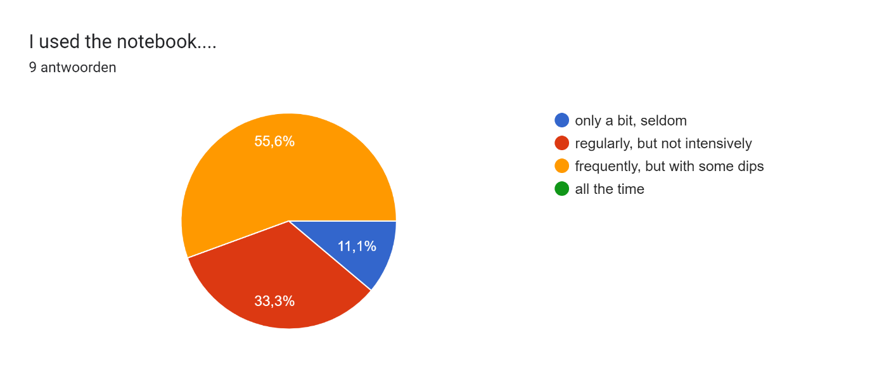

Advantages:

Good way of data collection, good way to not forget the details and every activity, good way of collecting information that we can use in personal life also

Collect the information and elaborate thoughts

Hand-brain connection. Visualisation.

Taking notes and ideas during sessions.

1) it helps me to focus when I find something difficult 2) it reminds me of what we saw during the day when there was a lot of input 3) it serves as a first filter before highlighting what could serve me as a person or the school or the 6clipsproject

It is good for taking private notes. Useful particularly outdoors when we didn't have our laptops.

It helped us be careful, take notes about everything we discussed. Remembering all the important things so it will be easy transfer then in the logbook and take them back home.

To remind me

You can put some extra, explaining that supports the powerpoint. You can put some notes for the practical implemantation of the project in your own school. You have something to use as a database for your thought

Disadvantages

No structure (free to write what we want, but could be more specific for data collection for the project itself), not enough time to write (the actual writing part on a notebook i find it hard while doing activities, foe example goint to visits, i prefer more the digital notebook, but another problem would be the lack of internet)

It's not easy to find always the time to fill it

You can forget it somewhere. Gets dirty, smashed.

it consist only basic information.

1) I tend to forget stuff and i had to think about taking it with me every time we went out 2) the different languages formed a barrier when we had to compare notebooks

For me it was a bit difficult to keep many notes mainly because I am not used to do so anymore on paper.

We have to take it with us every time.

You can forget somewhere,

When you are on de ground somewhere, it's not easy to use a notebook. There is a danger that the notebooks become too important during the course, so you miss important information while you were writing.

Participants looked at each others’ notebook – in a different language- and gave the following feedback:

-to use the space better (some pages were empty and the using of paper is important for climate change) - i liked the drawing part and that i can see what she wrote in the notebook by an image -maybe more details about what you are thinking or feeling (for personal notes)

It missed drawings and data. Still it was very ordered and presented lots of details

There could be more notes in notebook. The alinees are cool.

every style of notes is personal

I only saw one date, the first day.

Although I don't understand the language, it seems very well organized, filled with details, diagrams and draws that can be really helpful.

Hans was taking many notes in his language. He used it as a diary also. He could have used more colour and write a few more.

It is example of good work. It looks fine.

Ordering en refer to the day and PowerPoint that was used.

Conclusions: the 2 step notebook strategy will be used in the next course; only minor adaptations are needed. This is confirmed by Dataset 5.

**Dataset 4** : [The graphical expression of the learning during the week](https://drive.google.com/file/d/1ZMT1VVWfdx6jwQX9YCBfxNVT0CkFyokE/view?usp=share_link)

Examples:

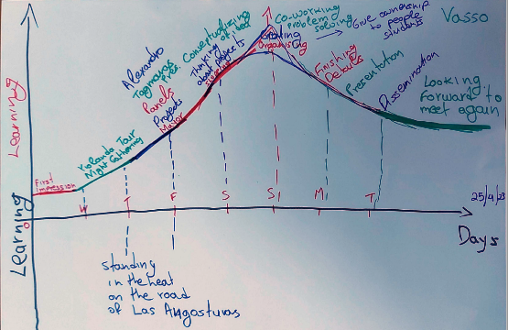

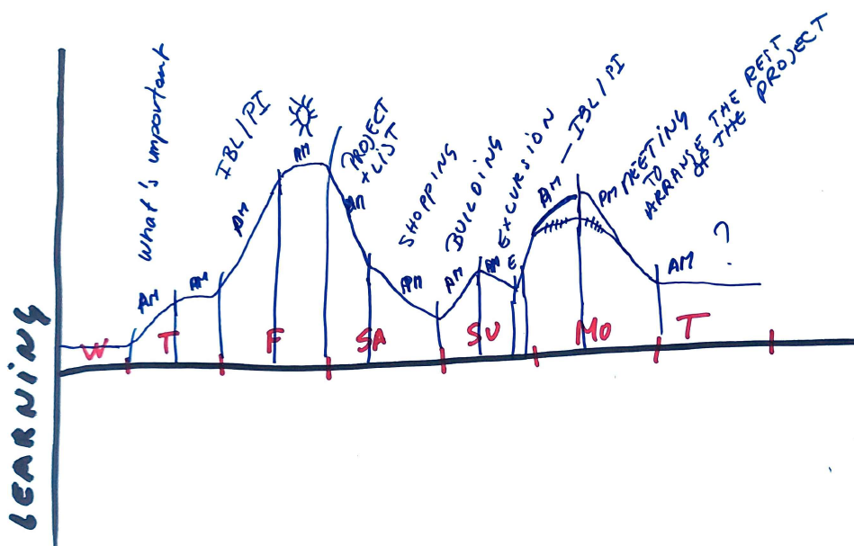

7 of these drawings were produced.

Observations:

The first day- the main activity,getting to know the venue, scored rather low on these graphs. The second day the tour by the goat keeper and the local expert on organic farming were a highlight, two mention the dinner prepared by a neighbour (but it was free time). The third day the absolute best moment was the visit to Alozaina, with the expert explaining the problems on solar panel parks. Also the “Caminito del Rey” walk was a highlight, while it was not a part of the course itself.

The next day, the engineering of the installations starts as a big learning time, but the shopping is a depth in all graphs. The technical realisation of the installations was appreciated a lot. Also the scientific experiments by the IBL expert were seen as very interesting.

Conclusions: the study visits and cultural activities were highly appreciated, even the optional free time activity of “Caminito del Rey”

Developing and building the installations was a very positive experience

The scientific experiments were highlighted too

**Dataset 5:** [The final survey](https://docs.google.com/forms/d/e/1FAIpQLSecUI3hiPALlhd89Ut0f6Ip7XOvm7T8lCbd7W7aCjUNij6nvQ/viewform?usp=share_link)

21 questions were posed, answers on a Lickert scale of 5 ranging

0: Absent/very poor/ not interesting

1: Limited/ weak

2: Present but not elaborated/ ok, but can be better

3: Good/ positive/ interesting

4: Very good/learningful/ a lot/ really interesting

The median is the most reliable answer, and the most appropriate for such small numbers of participants.

Results:

|  | How to work together as a PLC | The information on the local context given by experts (Yolanda, Alejandro, Marisa) | Cultural activities ( dinners, excursions to Alora and Malaga) | Use of logbook in the future, at school |
| --- | --- | --- | --- | --- |
| MEDIAN | 4 | 4 | 4 | 4 |
| AVERAGE | 3.56 | 4.00 | 4.00 | 3.44 |

For “The information on the local context given by experts (Yolanda, Alejandro, Marisa)” and “Cultural activities ( dinners, excursions to Alora and Malaga)” the answers were even unanimously “Very good”.

All other 13 Questions show a median of 3: Good/ positive/ interesting

Tour of the venue(3,22), Generating ideas on the TrainingProjects(3,22), Engeneering of the TrainingProjects ( engeneering, shoplist, buying materials)(2,67), Technology: Building the installations (2,89), Discussions as learning moments (2,67), Science: Gathering data / measurements (2,78), Doing/ discussing small science experiments (DS) (3,11), Preparation of presentations (2,89), Understand what Practitioners Inquiry is (3,25), Using Notebook (2,89), Link between the action and the theoretical framework (3,00), Making Clips (2,50), Usefullness of logbook of this week (3,22).

For additional information between brackets the average is mentioned.

The following 4 topics scored rather low:

|  | Doing SWOTs as reflection | Using recycable materials | Planning using BSC | Presenting to externals |
| --- | --- | --- | --- | --- |
| MEDIAN | 2.5 | 2 | 2 | 2 |
| AVERAGE | 2.63 | 1.89 | 2.44 | 2.00 |

Conclusions: 17 out of 21 items score “Good/ positive/ interesting” to “ Very good/learningful/ a lot/ really interesting”. The backbone of the course should be kept.

The SWOT as a separate feedback tool should be reconsidered.

Using recycled materials should either be left out or better materials should be put in place. *Idea: visit the Sunday second hand market in COIN.*

Presenting to externals is a typical project activity and can be left out. *Idea: do the presentation and invite a few locals.*

*PS For a PowerPoint presentation of the PI the graph with the analysis of the answers could be more attractive*

**Dataset 6:** The oral feedback ( interviews, talks)

* The venue and the location of the stay were very remote: this could frighten off some future participants
* The days were extremely intensive
* There was no time for relaxing
* The final exchange of small presents was a nice idea
* The transportation of the group with 2 cars was very efficient
* The 3 last breakfast shifted from the B&B to the venue because the atmosphere was better there

**Overall conclusions**

1. **What are the strengths and the weaknesses of the 6 CliPs training course?**

The strengths of the course are

* The study of the local context on different levels
* The cultural activities and the “Caminito del Rey”
* Dealing with the participants as a PLC
* Practitioner Inquiry as a tool for measuring the impact of teaching
* The use of the 2 step logbook
* The continuous feedback moments
* The STEAM strategy used ( Link between action and theory, tour of the venue, generating ideas, discussions, doing scientific experiments and introduction to IBL, engineering, building the installations, gathering data, preparations for presentations, the making of the Clips).

All the above mentioned strengths score very high in the final survey, and are well validated by outcomes of the analysis of the other datasets.

The weaknesses of the course are

* The visit to the recycling park leading to poor use of recycled materials. However, the participants support the idea as such, but the application of it is limited during the course days.
* The SWOT as feedback instrument
* The presentation to externals: these were done in the presence of only two externals, who left the aula after less than 15 minutes.
* The use of the Balanced Score Card

1. **Drawing conclusions, how should the course be reshaped for future use, keeping the main goals?**

Main changes to be made:

* Keep the STEAM cycle as guiding tool and planning instrument for the whole week
* Have all studies in or near the venue, inviting external experts there
* Keep the local dinner and the contact with the locals
* Implement the “Caminito del Rey” in the course itself
* Keep the excursion to Malaga, and combine maybe with a visit to Alozaina
* Make the shopping phase more efficient
* Extend the time dedicated to IBL experiments, and have them earlier in the week- combine IBL theory with IBL experiments and brainstorming; repeat as soon as the installations are engineered
* Keep the notebook as a tool for individual and shared learning, emphasise the importance of it during all activities
* Make the reflection more simple: add reflection to the notebook strategy and avoid the SWOT
* Avoid other specific 6 CliPs themes: BSC, presentation to externals, visit to recycling center ( but keep the principle).

IDEA: Change the E for electricity to E for energy (also heating/cooling)

IDEA: visit second hand market of COIN on Sunday

**This would lead to the following provisional scheme:**

**Day 1, Thursday**

9:00 Registration and the use of the Notebook, short introduction to the venue

10:00 Building a professional learning community: How to learn from each other in the most productive way

11:00 Break

11:30 Attributes of a PLC

12:00 Norms and values of a PLC

12:30 Walking tour of the environment of the venue with local inhabitant(s): discussing the situation on Water, Electricity and Plants

14:00 Lunch

16:30 Outdoor tour of the venue: with special attention to the WEP subjects; launching some preliminary ideas

18:00 Information on local context by IMAGINA

18:30 Information on local context of plants and water by the local expert Alejandro Hevilla.

19:30 Home-made dinner by locals as PLC activity and cultural exchange

**Day 2, Friday**

9:00 Individual reflection: important personal notes in the digital logbook + reflection on the course

9:30 What is STE(A)M education? Aspects of IBL. Examples of small experiments and IBL approach The role of Science and Math, and Technology and Engineering (design+ test). Discussions and reflections for personal learning.

12:00 Practitioner inquiry: principle and phases: steps: 10 mindframes of J. Hattie for enhanced impact on student learning; possible PI questions

12:30 Second tour of the venue, indicating some needs or subjects for improvement

14:00 Lunch

16:00 Brainstorming on possible small WEP installations. Initiating work teams based on interest and needs: selection of small WEP TrainingProjects in the venue; distribution of tasks ( based on one of the 12 steps, f.i. design, shopping, building, scientific measurements, presentations), updating shopping list

17:00 Teacher Teams elaborate initial ideas: design, engineering and construction. The use of recycled or natural materials available;

18:30 Shopping list for small WEP TrainingProjects

19:00 Guided Tour of Alora

20:00 Dinner at local tapas bar in Alora as PLC activity and cultural exchange

**Day 3, Saturday**

9:00 Individual reflection: notes in the digital logbook + reflection on the course

9:30 Finetuning design of Installations; planning; suggestions for scientific measurments and science IBL experiments related to the installations; updating shop list

10:30 Alternative Excursion to Alozaina, meeting with "plataforma MacroRenovablesNo". Expert Marisa Casal and Major of Alozaina If not: longer on the previous topic and leaving at 11:30 for shopping round.

12:30 Shop Vivero Guzmann for plants

14:00 Lunch Guadalmar

16:00 Shop Obramat

18:30 Visit to Malaga Centre.

20:00 Course Dinner

**Day 4, Sunday**

9:00 Individual reflection: notes in the digital logbook + reflection on the course

9:30 Building installations

9:30 Alternative: visit second hand Market of COIN for recluced materials

11:00 Feedback of "externals" to the installations

12:00 Building installations + start scientific measurements

14:00 Lunch/ Free afternoon

Optional: Caminito del Rey+Garganta+ dinner

**Day 5, Monday**

9:00 PI: possible PI questions for teachers in the schools

9:30 Elaborating: construction of WEP installation

10:30 Break

11:00 Elaborating: data collection/ measurements on installations

12:30 Preparation of presentations + finetuning

14:00 Lunch

16:00 Preparation of presentations (PowerPoint or Clips)

18:30 Presentations of small installations

End: 19:30

**Discussion**

This PI serves many goals

1. To show the format of a PI to the teachers of the 6 CliPs project.
2. To show that many ways of gathering data are possible. In this case it is maybe overdone a bit: maximum 3 different kinds of data are sufficient. Data can be general or specific, and can have many different shapes.
3. To make the learnings of the tutor more explicit, resulting in a change of his practice, in this case the development of an updated 6CliPs course. This was my need as professional. Another need could have been formulated as follows: “*In what ways did this course enhance the learnings of the participants, in view of the learning goals of the 6 CliPs project?*  The answer to that question can also be extracted from more or less the same data, only a different analysis would be needed.
4. To motivate the 6CliPs teachers to carry out a similar PI, twice, each connected to the learnings of the students during each of the 2 developments of an installation, and the consequences for their practice.

**Acknowledgements:**

In the first place, I thank all participants of the 6 CliPs training course in Álora for making it to a wonderful learning experience for me. I also thank the experts that made the course of such high quality: Dagmara, Yolanda, Alejandro and Marisa. I also thank IMAGINA for their valuable and high levelled contribution to this unique course.

**References:**

1. The “KA210-SCH-4A6E0B46 Final. “ ( = 6 CliPs ) proposal
2. Def: “Dana and Yendol-Hoppey (2009) define teacher inquiry as **a systematic intentional study of one's own professional practice**. The process involves forming questions or “wonderings,” collecting data based on those questions, analyzing the data, and sharing one's findings.” Please watch the videos of Nancy Dana ( U Florida) on <https://www.drnancydana.com/inquiry-videos> to get a quick understanding of the basics of PI.
3. <https://steamit.eun.org/>